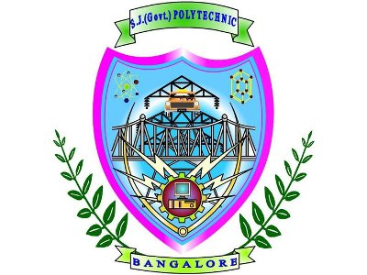

****SRI JAYACHAMARAJENDRA (GOVT.) POLYTECHNIC**  
**Department of Computer Science Engineering****

### ****Industrial Visit Report****

#### ****Organization****: Cognizant

#### ****Industry Name****: Cognizant Technology Solutions

#### ****Date of Visit****: October 29, 2024

#### ****Submitted By****:

**Name**: Kaveri R.  
**College**: S. J. (Govt.) Polytechnic, Bangalore  
**Roll No.**: 102CS22020  
**Department**: Computer Science Engineering

#### ****Submitted To****:

**Faculty Guide**: Prof. Savitha Kamalapurkar

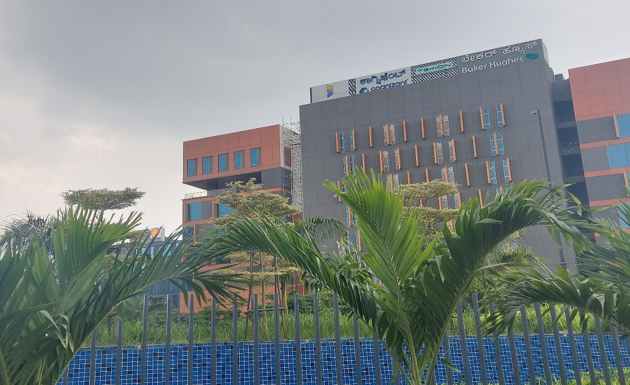

1. **Acknowledgment:**

We extend our sincere gratitude to Cognizant for providing this invaluable opportunity to participate in their mock interview workshop. This event was designed to give students practical insights into real-world interview scenarios and equip us with the skills needed to approach interviews confidently.

1. **Introduction:**

**Purpose:**  
The mock interview workshop aimed to bridge the gap between academic learning and professional expectations. Through this program, Cognizant sought to help diploma students gain familiarity with interview processes, technical and behavioral questioning, and the skills essential for early career roles in the tech industry.

**Cognizant Overview:**  
Founded in 1994, Cognizant is a global leader in consulting, IT services, and digital transformation solutions, headquartered in New Jersey, USA. The company has consistently been among the top technology service providers, focusing on cutting-edge digital services to enhance business operations across industries.

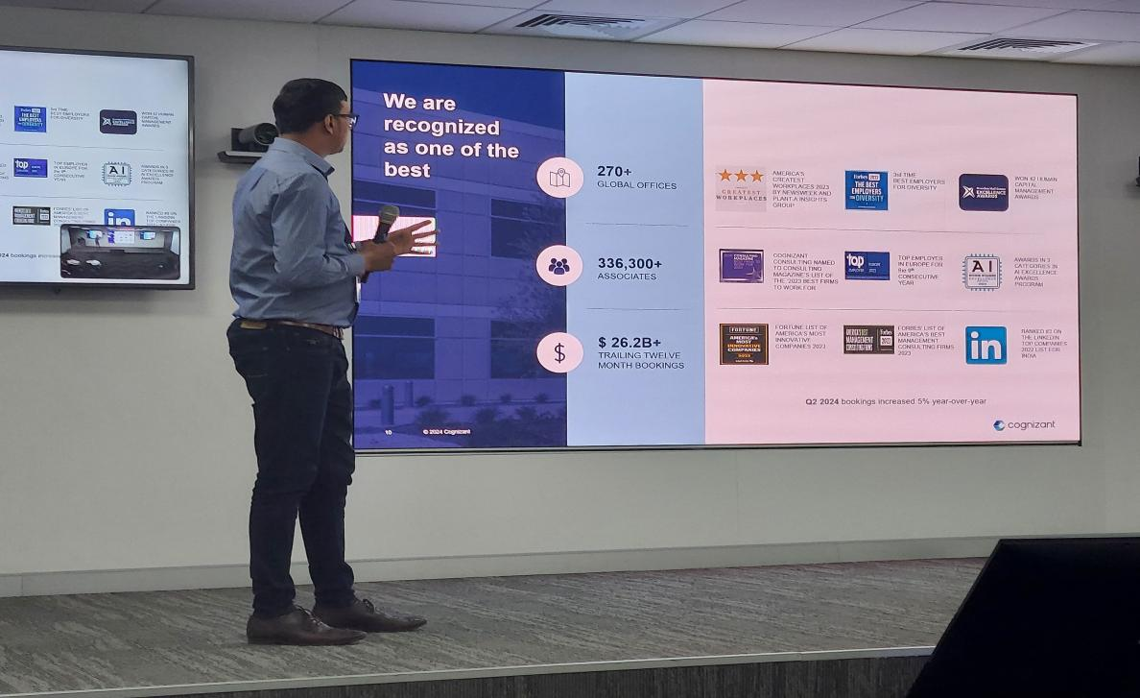

**3. Objectives of the Workshop**

1. **Interview Preparation:** Equip students with the knowledge and strategies to approach technical and behavioral interview questions.
2. **Practical Experience:** Provide mock interview sessions, allowing students to experience real-time feedback and improve interview skills.
3. **Industry Insights:** Share insights on industry expectations, career paths in technology, and essential skills for job readiness.
4. **Confidence Building:** Offer sessions on public speaking, resume building, and confidence enhancement, key for excelling in interviews.

**4. Workshop Agenda**

The workshop comprised a series of activities designed to simulate an interview environment and educate students on important aspects of interview readiness.

* **Introduction to the Cognizant Work Environment:** An overview of Cognizant’s values, work culture, and what the company expects from entry-level employees.
* **Technical Interview Tips:** Guidance on technical areas relevant to diploma students, including programming languages, problem-solving skills, and technical concepts.
* **Behavioral Interview Techniques:** Tips on answering behavioral questions, focusing on the STAR (Situation, Task, Action, Result) method to structure responses.
* **Resume Review and Feedback:** Cognizant HR representatives reviewed resumes, provided constructive feedback, and shared tips for making resumes stand out.
* **Mock Interviews:** A simulated interview session with Cognizant professionals, where each student received personalized feedback on performance and improvement areas.

**5. Key Sessions and Activities**

1. **Opening** **Keynote:**  
   The workshop began with a welcome speech from a Cognizant senior executive, highlighting the significance of strong interview skills and the current demand for skilled professionals in the technology sector.
2. **Technical Interview Simulations:**  
   Conducted by Cognizant software engineers, these mock interviews focused on assessing students' knowledge in programming (e.g., Python, Java), data structures, and problem-solving skills. Each student was encouraged to think critically and demonstrate logical approaches to technical problems.
3. **Behavioral Interview Guidance:**  
   A session led by Cognizant HR emphasized soft skills, such as teamwork, adaptability, and communication. Students practiced responding to situational questions, such as handling conflict or demonstrating initiative, using the STAR method.
4. **Panel Discussion – Pathways in Technology:**  
   A panel of Cognizant professionals from different backgrounds shared their career journeys, offering advice on the diverse roles within technology and how students can prepare for various career paths in the industry.
5. **Personalized Feedback Sessions:**  
   After the mock interviews, each student received personalized feedback from the interviewers. This included strengths, areas for improvement, and specific tips to enhance technical and communication skills.
6. **Networking and Q&A:**  
   Students had the opportunity to network with Cognizant professionals, ask questions about career growth, industry trends, and gain insights into the technology landscape.

**6. Observations and Key Takeaways:**

* **Real-World Interview Experience:** Students experienced first-hand the structure and flow of technical and behavioral interviews, gaining practical experience that is otherwise unavailable in academic settings.
* **Importance of Soft Skills:** Behavioral questions emphasized the value of teamwork, leadership, and adaptability, which are crucial for fitting into company cultures like Cognizant’s.
* **Critical Thinking for Technical Questions:** The mock technical interviews taught us how to approach problem-solving methodically and communicate our thought processes clearly, which is vital for success in real interviews.
* **Resume Enhancement Tips:** Feedback on resumes underscored the importance of showcasing relevant projects, skills, and experience concisely, helping to increase Employ ability.

1. **Learning Outcomes:**

**1.Improved Interview Skills:** This workshop increased our confidence in answering both technical and behavioral questions effectively.

**2.Enhanced Understanding of Industry Expectations:** We now have a better understanding of the skills and attributes Cognizant values, such as adaptability, problem-solving, and technical knowledge.

**3.Career Awareness:** The event motivated students to pursue career pathways in technology, and equipped us with a clearer understanding of Cognizant’s roles and opportunities.

**8. Conclusion:**

The Cognizant Mock Interview Workshop was a transformative experience for students, bridging the gap between academia and the professional world. This workshop provided us with a realistic perspective on interview processes and industry expectations. Equipped with practical knowledge and feedback, we now feel better prepared to pursue roles in technology, confident in our ability to contribute to a dynamic organization like Cognizant.

1. Annexures: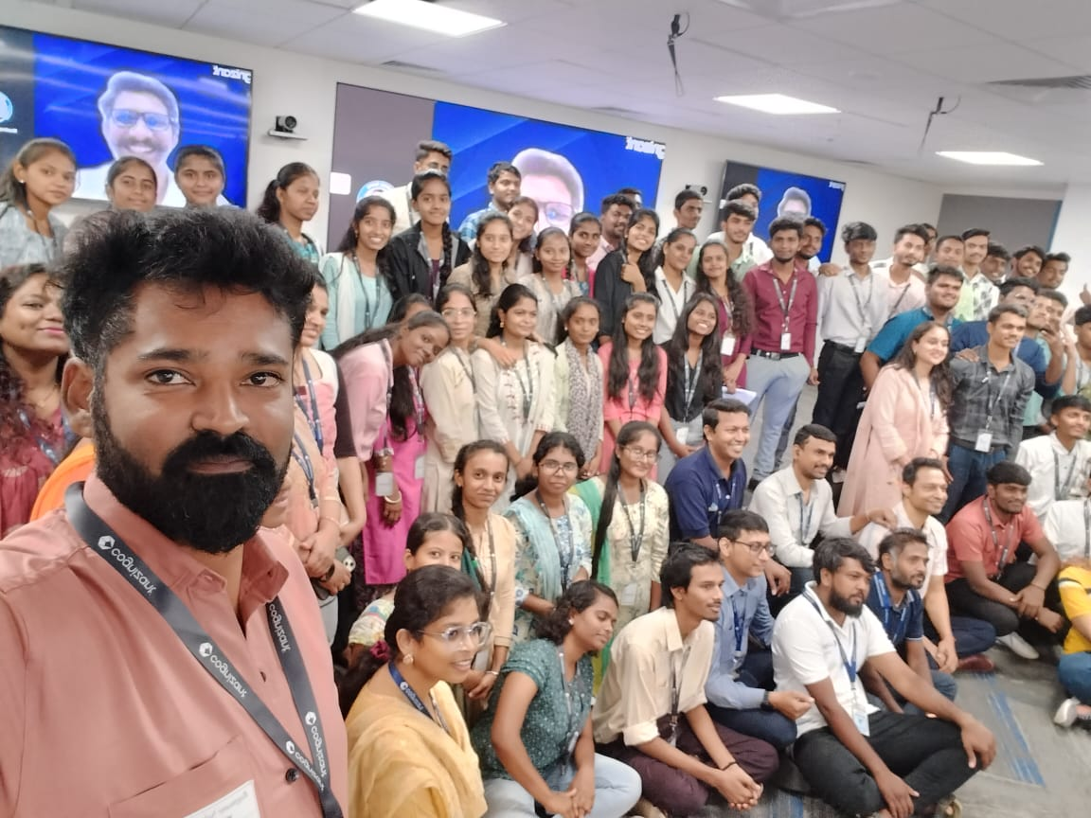Bottom of Form



THANK YOU